A WEB- BASED HOMEOWNERS ASSOCIATION
INFORMATION MANAGEMENT SYSTEM FOR
50,000 RESIDENTS TO
LANCASTER RESIDENCES PHASE 2

A Capstone Project Proposal
GROUP MEMBERS:
Prince Lawrence Suanino
Khacety M. Calapano
July 18 2026

INTRODUCTION
Homeowners associations (HOAs) are responsible for managing residential communities by maintaining homeowner records, disseminating announcements, handling complaints, monitoring dues, and ensuring compliance with community policies.
As residential communities continue to grow, relying on manual processes such as paper records, spreadsheets, and social media communication becomes inefficient and prone to errors.
Information technology provides an opportunity to improve HOA operations by digitizing records, streamlining communication, and increasing the efficiency of administrative services.

Project Context
Homeowners associations are responsible for maintaining an organized, secure, and well-managed residential community. As communities expand, the volume of homeowner information, announcements, complaints, and administrative records also increases, making manual management more difficult.
The use of a web-based information management system provides a modern solution that improves efficiency, communication, and data management.
Overall, the project supports the digital transformation of Lancaster Residences Phase 2 by introducing a user-friendly and secure webbased information management system that benefits both administrators and homeowners.

Purpose and Description
Digitize and organize homeowner information in a centralized database.
Improve communication between the homeowners association administrators and residents through online announcements and notifications.
Provide an efficient platform for submitting and monitoring homeowner complaints and requests.
Simplify the management of billing records, payments, and other association-related transactions.
Generate accurate reports that support administrative decisionmaking.

Statement of the Problem

How can a web-based information management system improve the management of homeowner records in Lancaster Residences Phase 2?
How can the proposed system provide an efficient platform for posting announcements and improving communication between the homeowners association and residents?
How can the system simplify the submission, monitoring, and resolution of homeowner complaints and service requests?
How can the proposed system improve the monitoring of billing records, payments, and other association transactions?
How can the system generate accurate and timely reports to support the administrative needs of the homeowners association?
How acceptable is the proposed Web-Based Homeowners Association
Information Management System in terms of, Functionality, Reliability,usability, efficiency, security.

Objective of the Study

- To design and develop a web-based system that securely manages and stores homeowner information for Lancaster Residences Phase 2.
- To provide an efficient platform for managing announcements, homeownercomplaints, and service requests to improve communication between the homeowners association and residents.
- To develop a billing and payment monitoring module that records association duesand generates accurate transaction records and reports.
- To implement a secure and centralized database that improves data accuracy,minimizes paperwork, and enhances the efficiency of homeowners association operations.
- To evaluate the developed Web-Based Homeowners Association Information
Management System based on functionality, reliability, usability, efficiency, and security.

Scope

Homeowner registration and profile management.
Administrator and homeowner user accounts with secure login.
Announcement and notification management.
Complaint and service request submission and monitoring.
Billing and payment record management.
Report generation for homeowner information, complaints, billing, and payments.
Dashboard for monitoring homeowner associatio activitieses.

Secure database for storing and managing association records.

Billing Amount
Calculates and records homeowners' monthly or annual association dues. Displays the total amount due and payment status.
Car Sticker Management
Registers vehicle information.
Issues and monitors homeowners' car stickers.
Tracks active and expired stickers.
Homeowners Billing
Creates billing records for each homeowner.
Records payment history and outstanding balances.
Penalty Management
Automatically computes penalties for late payments based on HOA rules. Displays penalties together with the total amount due.
Reminders
Sends or displays reminders for upcoming due dates, unpaid bills, and importan announcements.
Notifies homeowners of overdue accounts.
Summary
Generates a summary of billing, payments, penalties, and homeowner records.
Provides reports for administrators.
Overdue Monitoring
Lists homeowners with overdue payments.
Displays the number of overdue days and total outstanding balance. Action to Solve
Allows administrators to record actions taken to resolve homeowner concerns or unpaid accounts, such as sending reminder notices or scheduling meetings.
Action Taken
Maintains a record of completed actions, including payment confirmation, complaint resolution, penalty settlement, or account updates.

Limitation

- The system is intended only for the Homeowners Association of Lancaster Residences Phase 2.
- Only authorized administrators and registered homeowners can access the system.
- Online payment processing is not included; the system only records and monitors billing and payment transactions.
- The system depends on a stable internet connection for online access.
- SMS and mobile application support are not included in this study. ● The system does not integrate with external government agencies, banks, or third-party payment gateways.

Review of Related Literature

Management Information Systems: Managing the
Digital Firm – Laudon & Laudon (2022)
Relevance: Shows how information systems improve data management, communication, and organizational efficiency.
Principles of Information Systems – Stair & Reynolds (2020)
Relevance: Explains that web-based systems provide faster access to information and improve administrative processes.
Software Engineering: A Practitioner's Approach – Pressman &
Maxim (2020)
Relevance: Supports the development of a secure, reliable, and userfriendly web-based information management system.

Project Design & Development

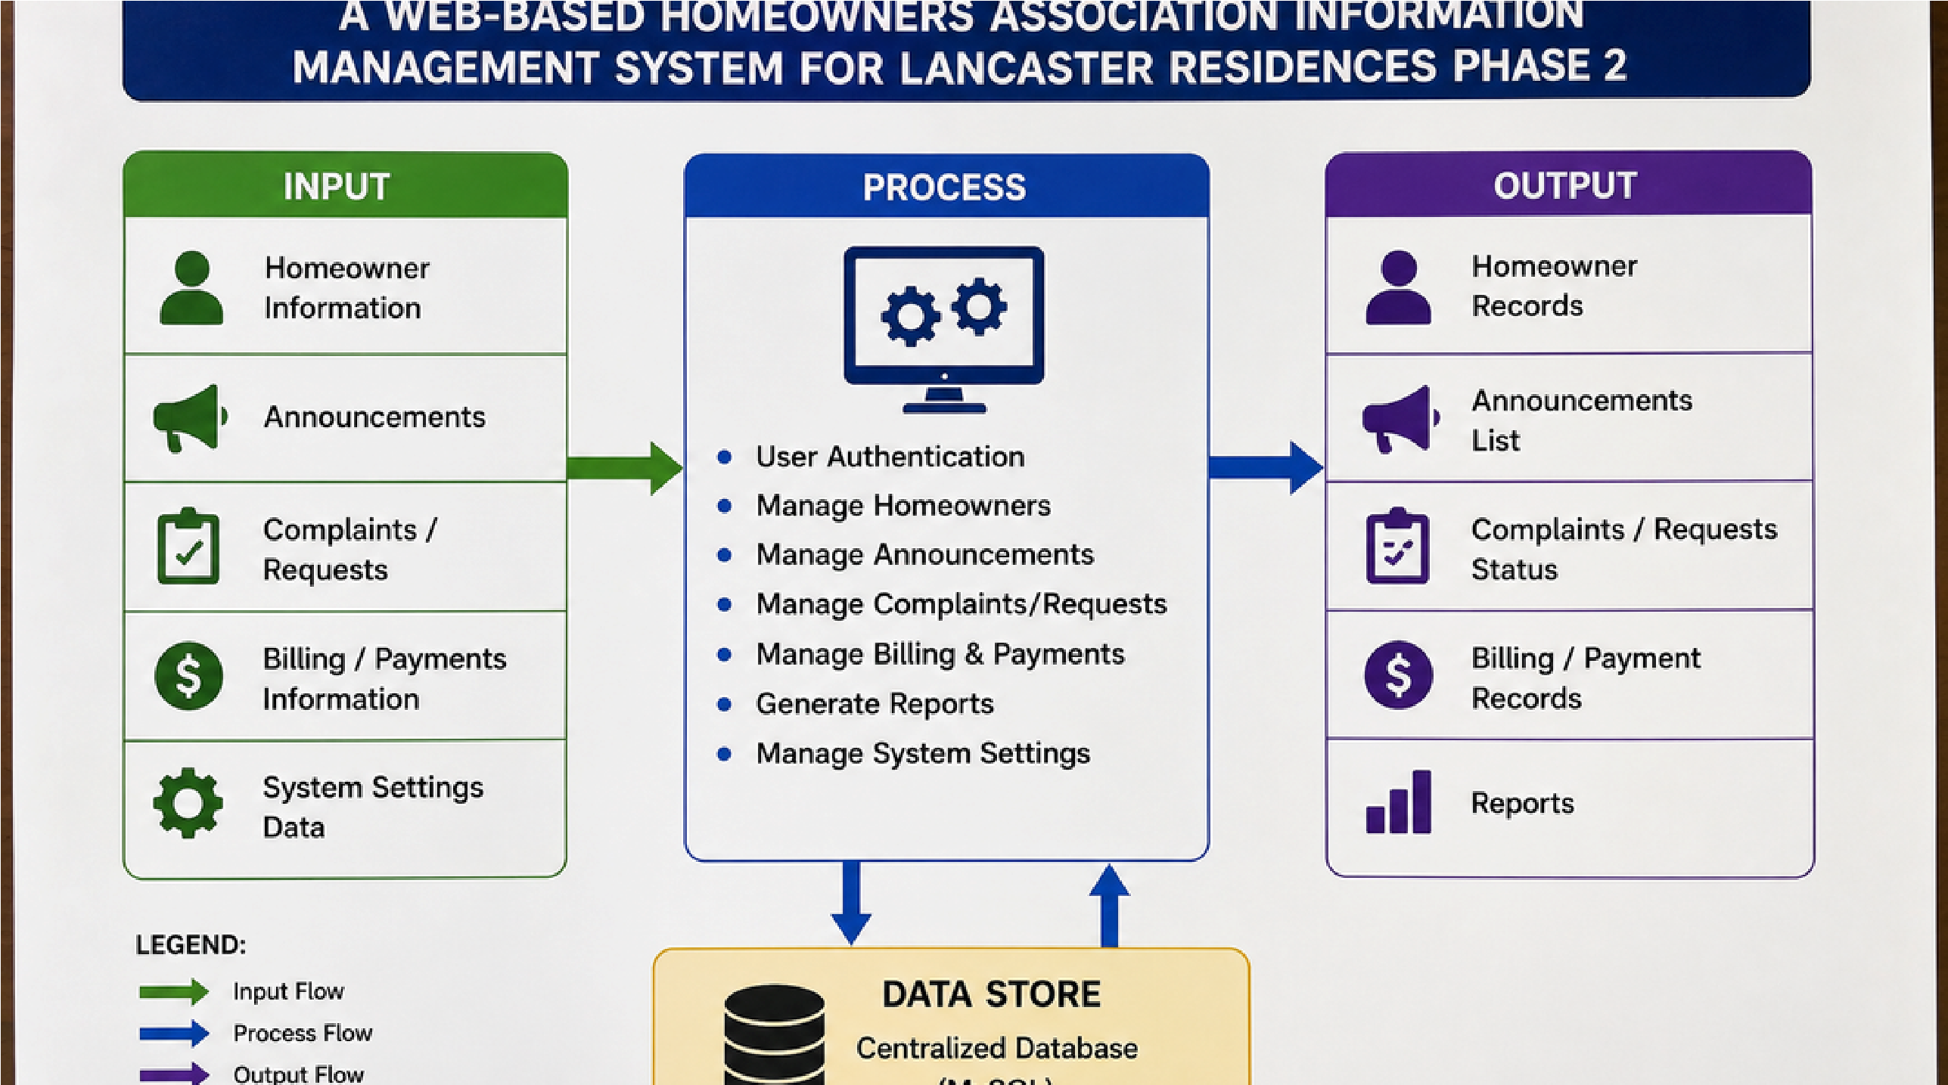
Project Design & Development

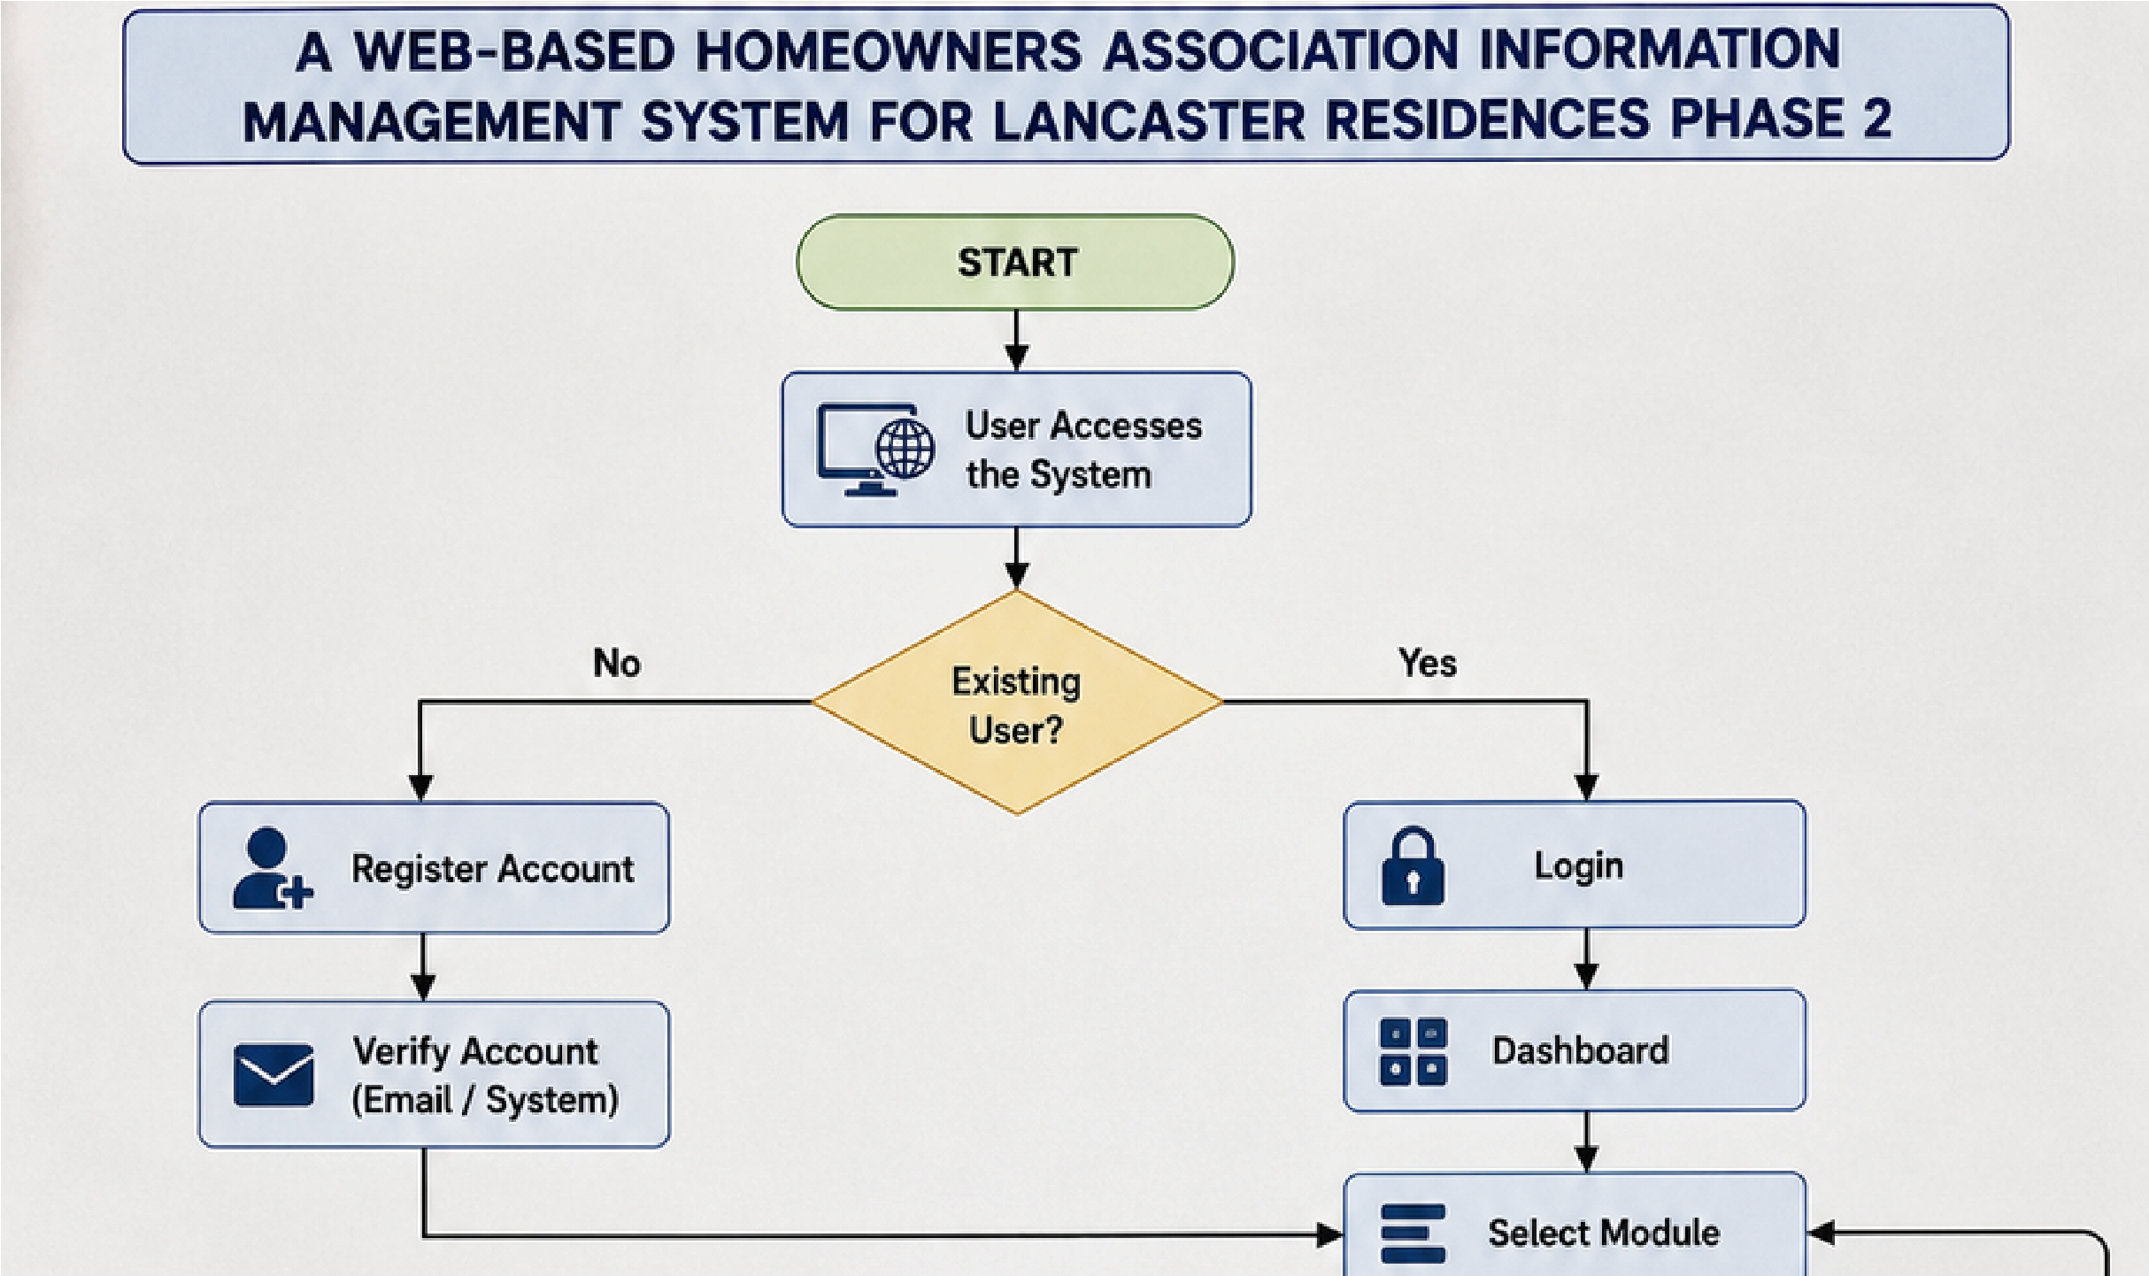
Project Design & Development

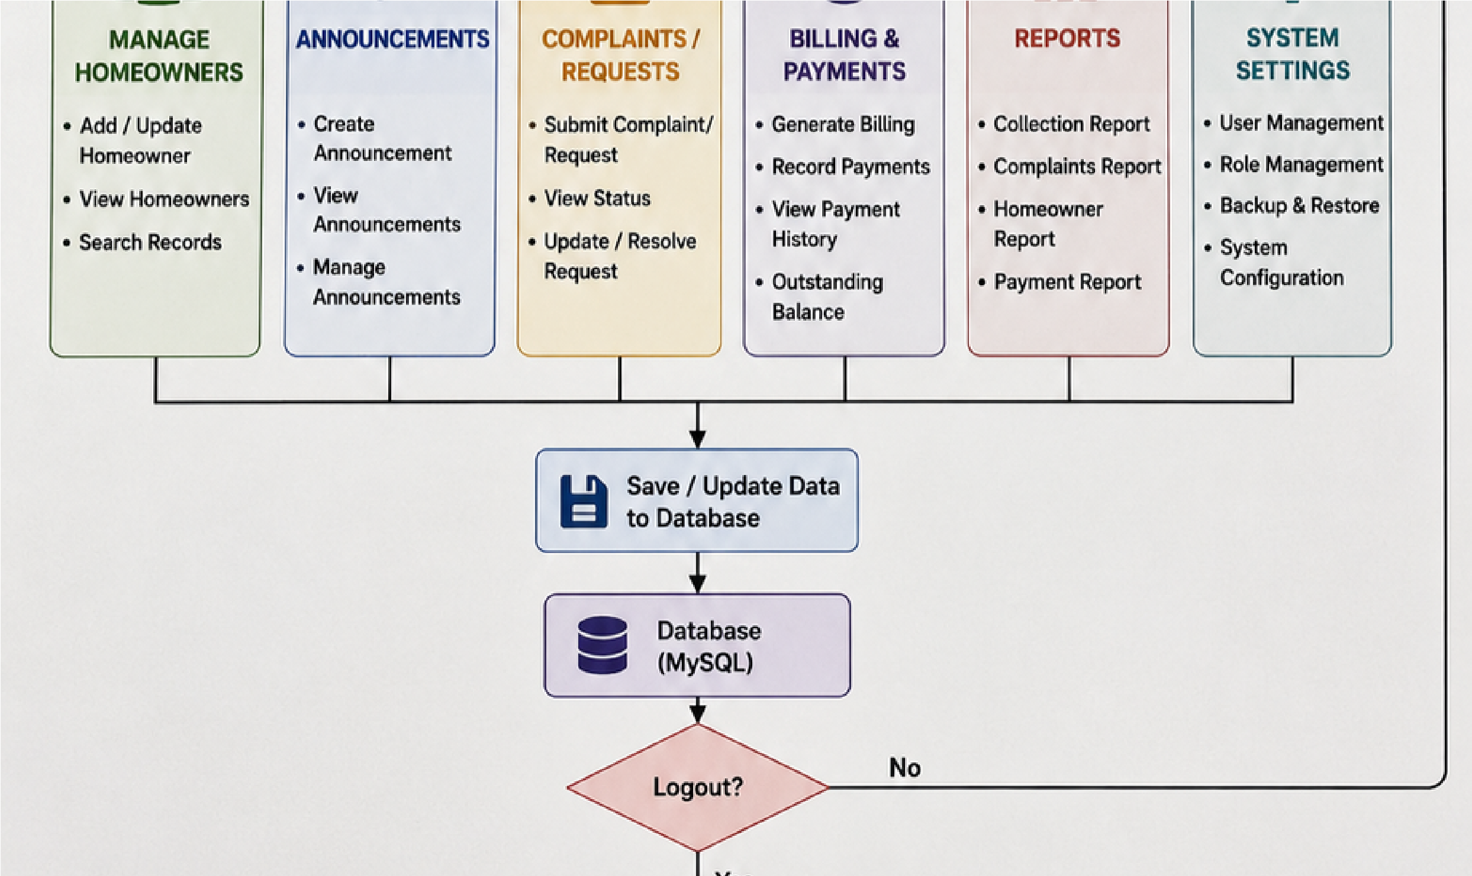

Propose Design of the system

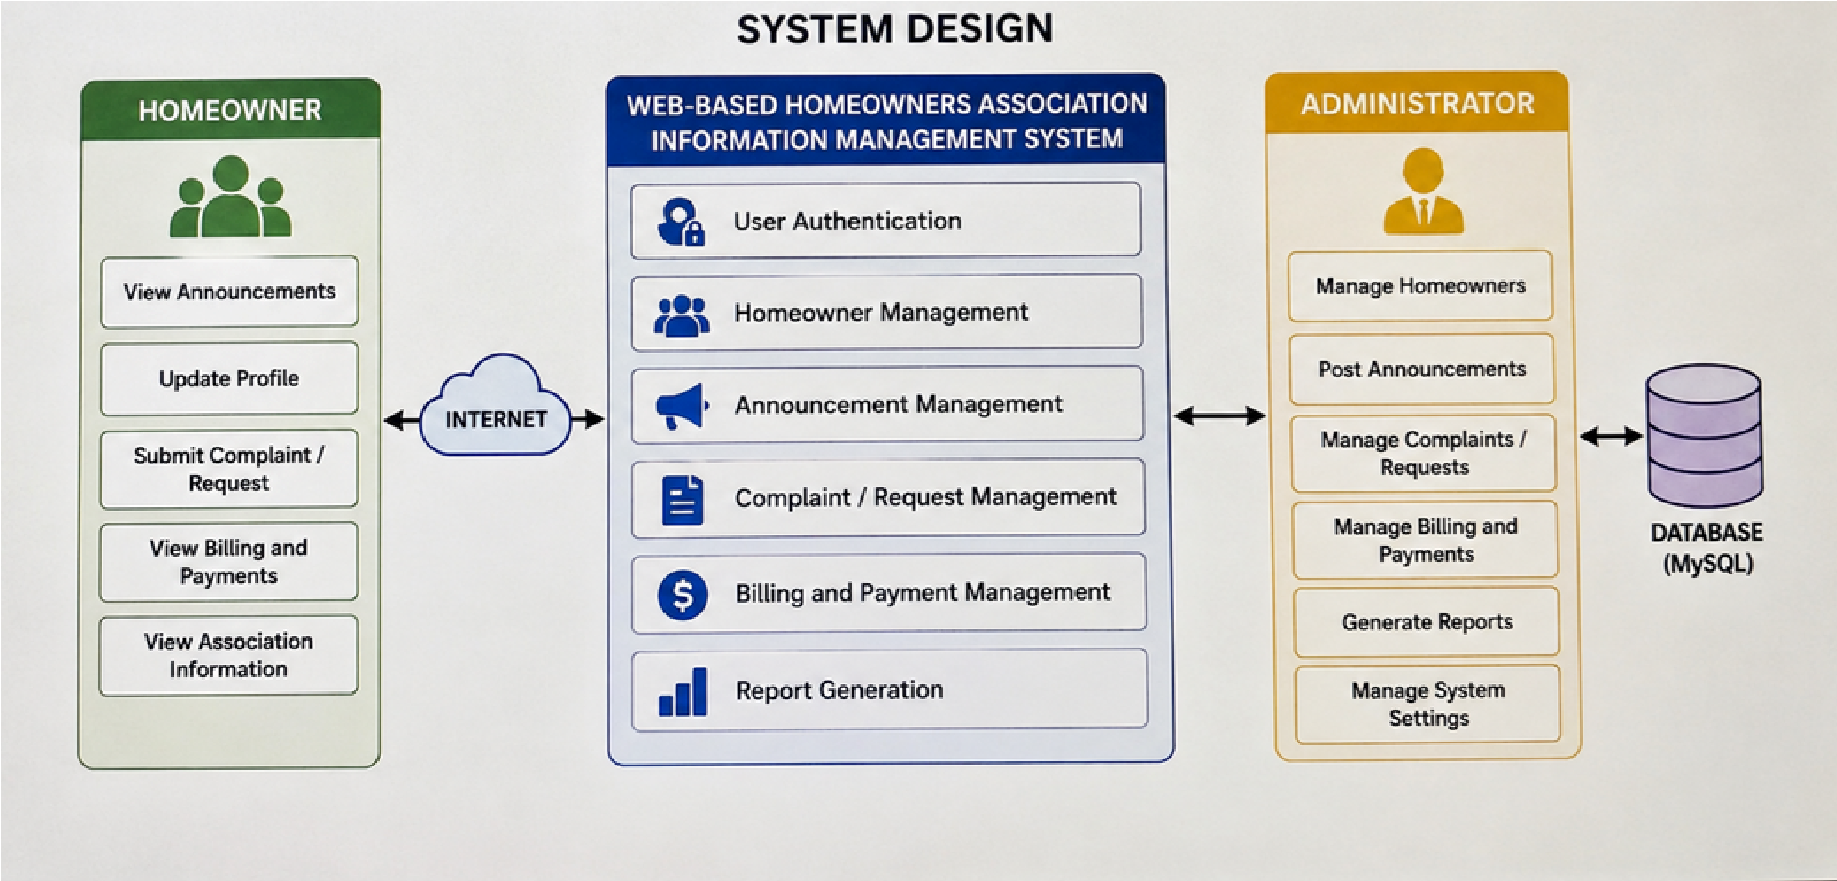
References (Bibliography)
Laudon, K. C., & Laudon, J. P. (2022). Management information systems: Managing the digital firm (17th ed.). Pearson.
Pressman, R. S., & Maxim, B. R. (2020). Software engineering: A practitioner's approach (9th ed.). McGraw-Hill Education.
Sommerville, I. (2016). Software engineering (10th ed.). Pearson.
Stair, R. M., & Reynolds, G. W. (2020). Principles of information systems (13th ed.).
Cengage Learning.
Turban, E., Pollard, C., & Wood, G. (2018). Information technology for management: Ondemand strategies for performance, growth, and sustainability (11th ed.). Wiley. Republic of the Philippines. (2012). Republic Act No. 10173: Data Privacy Act of 2012. https://privacy.gov.ph/data-privacy-act/

Thank you

